EEMEM0018 Lab Activity 5 - Data in the IoT Cloud

- Objectives
- Introduction
- Required Equipment and Components
  - Hardware:
  - Software:
- Project Setup
- Task 1: Firmware
  - Task 1.1: Connectivity with the Gateway
  - Task 1.2: Verify MQTT functionality
- Task 2: Visualise your Data in the IoT Cloud
  - Task 2.1: Find your device in the IoT Cloud
  - Task 2.2: Read and Interpret your Data
  - Task 2.3: Create your own Dashboard
- Task 3: Independent Activity - Experiment with ThingsBoard Features
- Try this at Home
  - Scenario 1: Use your own gateway and nRF54L15DK
    - Register a gateway device on ThingsBoard
    - Use a locally-installed MQTT broker (Optional)
    - Push data to the ThingsBoard Cloud
  - Scenario 2: End-to-End MQTT with an Emulated Device.
  - Scenario 3: (Optional, Advanced): Experiment with Alternative Transports
- References

Objectives
At the end of this laboratory session, you will be able to:
- Generate sensor data from your device and transmit them over BLE to a Cloud IoT Platform (ThingsBoard).
- Use ThingsBoard to view your device and its data, and to create data visualisations.

Introduction
In this exercise, you will put together the end-to-end picture. Your firmware will collect sensor readings and transmit them to a cloud IoT Platform. You will make sure your device is communicating with the platform successfully, and you will create end-user visualisations of the data collected by your device.
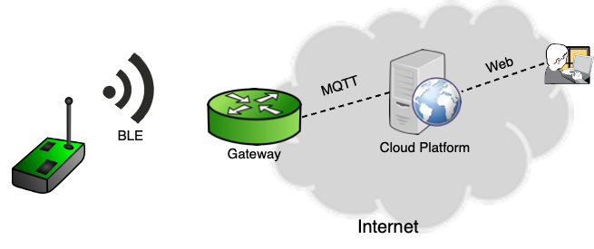
Figure 1: Concept Architecture
Figure 1 illustrates the concept. On the left hand side, an IoT device communicates over BLE with a Gateway. The gateway collects the payload of BLE packets and repackages it into MQTT messages that is published to a cloud platform on the internet. Users interact with the platform over the world wide web.
This is not the only possible solution, there are other solutions involving different protocols and possible even direct end to end communication (e.g. over IPv6) between the IoT Device and the platform.
In our specific case:
- The IoT device corresponds to your nRF54L15DK temperature sensor
- The Gateway is a custom-written Python script that will run on the teaching team's computer. You will not have access to it.
- The Cloud Platform is ThingsBoard Cloud.

Required Equipment and Components
For this lab session you will need the same setup as you used in session 4:

Hardware:
- nRF54L15 DK Development Kit
- LM335 analogue temperature sensor
- 330 Ω series resistor (for 3.3 V operation)
- Breadboard and jumper wires
- USB-C cable

Software:
- A computer with your VS Code development environment
- Your complete Lab 4
- (Optionally) a desktop or mobile scanner app as you used in sessions 3 and 4.
- (Optionally) A ThingsBoard Cloud account. We will generate account activation links for you, but you will need to activate your account. Please note that ThingsBoard is not a University-provided service, so make sure you have read and understood its Terms and Conditions and Privacy Notice before deciding whether you wish to activate you an account or not. If you do not activate your account, you will be able to view visualisations created by othrs and by the session lead, but you will be unable to make any of your own modifications.

Project Setup
- Make sure you have a working development environment that communicates with your nRF54L15DK kit.
- Make sure you have set the ADC reference voltage to 3.3V using the Board Configurator. If you are uncertain about this step, re-visit the respective section of the Lab 2 session.
- Make sure the temperature sensor is physically connected to your board, again as per the activity in lab sessions 2 and 4.

Task 1: Firmware

Task 1.1: Connectivity with the Gateway
Open your development and environment, build your lab 4 firmware and programme your device. Start your device. The gateway will already be running in the lab and after a few seconds we will see on the projector that a packet has been received from your device and that it has the correct format. The printout will look something like this:
[2026-02-09 12:54:39,513 - Scanner - INFO] EEMEM0018 Lab: G=0, T=16, V=2896, RSSI=-51
[2026-02-09 12:54:39,518 - Scanner - INFO] MQTT: Publishing, P='{"Group 0 Device": [{"temperature": 16}, {"voltage": 2896}, {"rssi": -51}]}'
The first line: Contains the following information:
- Device Name from the BLE AD0
- Manufacturer Specific Data from BLE AD1:
  - Group Number (G=0)
  - Temperature (T=16)
  - Raw ADC output voltage (V=2896)
Your device did not transmit anything else. Where did RSSI come from?
The second line is a JSON [1] object: JSON (JavaScript Object Notation) is an open standard file format and data interchange format that uses human-readable text to store and transmit data. The object here can be reformatted as per the snippet below. This reformatting is purely for the purpose of improving readability, the JSON objects themselves are 100% functionally equivalent:
{
"Group 0 Device": [
{
"temperature": 16
},
{
"voltage": 2896
},
{
"rssi": -51
}
]
}
Your device did not transmit JSON either. Where did this JSON output come from?

Task 1.2: Verify MQTT functionality
An MQTT broker (Mosquitto) and MQTT subscriber are running on the teaching team's computer. If your packet is decoded successfully by the gateway as per the output above, its payload will get published to this broker. The subscriber has subscribed to all topics and should receive the respective publish message.

Task 2: Visualise your Data in the IoT Cloud

Task 2.1: Find your device in the IoT Cloud
Once we are satisfied that your devices can communicate with the gateway successfully, we will switch the gateway to publish MQTT messages directly to ThingsBoard.
The ThingsBoard cloud design is framed around the concepts of "Entities" and "Relationships". One type of entity is called "Tenant".
Think of a ThingsBoard tenant as a separate business entity. This is the individual or organization that owns or manufactures the devices and assets. A Tenant may have multiple customers. Each Tenant or Customer can have a number of users, devices and other assets.
In our lab session, the unit delivery team members are users that are grouped as a Tenant. Each student group is a customer. And each student is a user within that respective customer. This has been pre-configured for you.
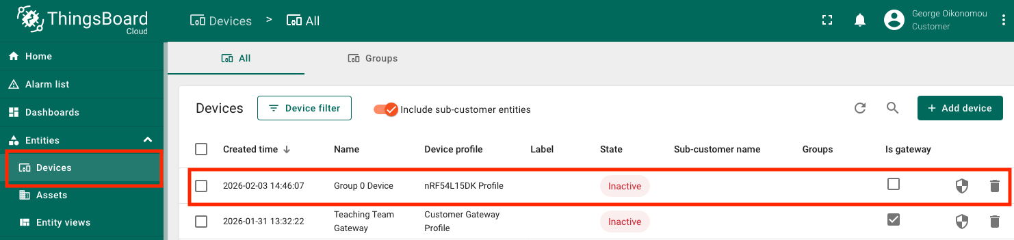
Figure 2: Devices on ThingsBoard
When ThingsBoard receives your device's data, the "State" column will change to "Active". Click on your device's row in the table and select the "Latest Telemetry" tab in the popup. If everything has gone well, your device should have started submitting its data ("telemetry"). The "Last update time" should show you the timestamp of the most recently-received message.
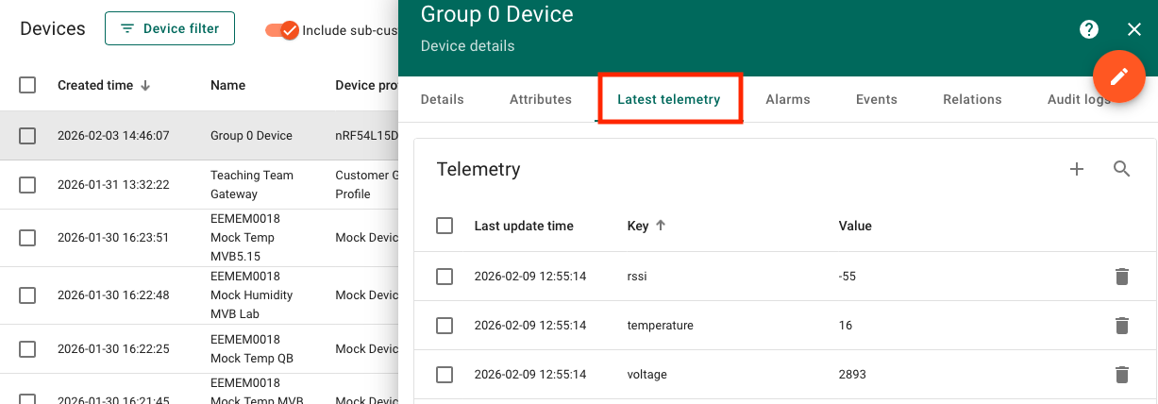
Figure 3: Telemetry data

Task 2.2: Read and Interpret your Data
Time to start viewing our data. This is done through Dashboards. We have already created a Dashboard and made it available to all customers (student groups). If all has gone to plan, then each group will only be able to see data from its own devices, despite the fact you are looking at effectively the same dashboard. Open it through Dashboards / Shared / EEMEM0018 Lab Dashboard.
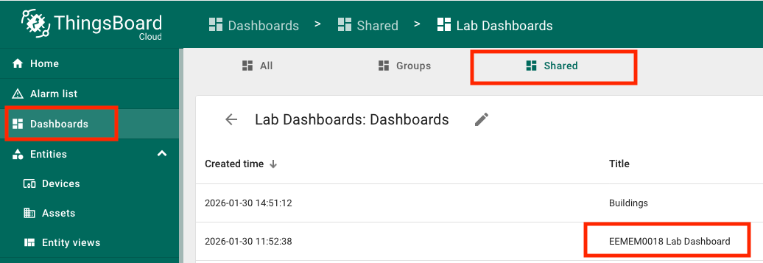
Figure 4: Opening the shared dashboard
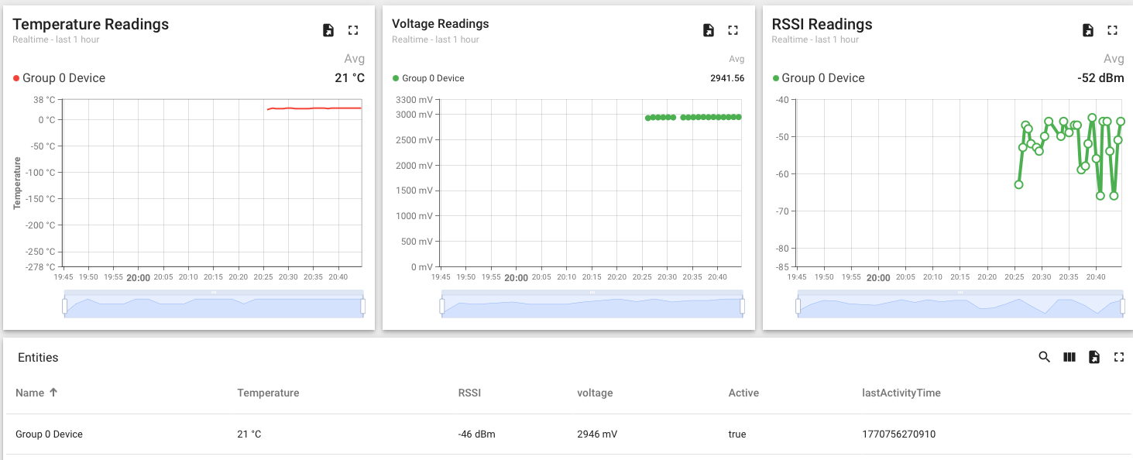
Figure 5: The shared lab dashboard
The top row shows three charts. They appear identical, but they are in fact three different chart types. Temperature is a "Time Series" chart, Voltage is a "Point Chart" and RSSI a "Line Chart". The differences are subtle.
The bottom of the dashboard is an "Entity Table" and shows information about your group's device.

Task 2.3: Create your own Dashboard
Time to experiment!
Go to Dashboards from the list on the left, choose the "All" tab and click the "Add Dashboard" button. Give it a title. Optionally, a background image and a description. Make sure "Owner" under "Owner and groups" shows your group name.
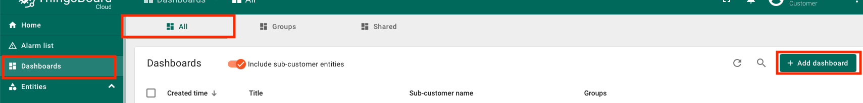
Figure 6: Add a dashboard
Open the newly-created dashboard and click "Add Widget". You will probably want to start with a simple chart. To draw the content of a chart, ThingsBoard uses a "Datasource". A Datasource can be a device, or an "Entity Alias". Start with selecting "Device" and, from the list, your group's only device. This will create a chart for you to start experimenting with. Importantly, this chart will only ever display data from this specific device.
To make multiple devices appear on the same chart, as has been shown on screen in the lab, you need to switch the Datasource from "Device" to "Entity Alias". An entity alias is effectively a grouping of entities of the same type. All your devices have a "Device profile" (imagine this as corresponding to a specific device type. So you can, for example, create an "Entity Alias" for all devices of a certain profile. There are more advanced ways of specifying aliases.
Create a second chart. Set Datasource to Entity Alias. You have not defined any aliases yet, so select "Create new". Give it a name, and under "Filter Type" select "Device Type". Select the "nRF54L15DK Profile".
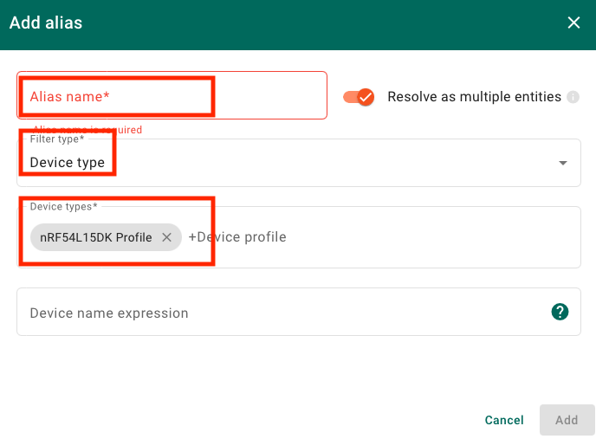
Figure 7: Define an Entity Alias
When you are finished, the two charts should be in perfect sync. Except if you were to add a second device, one chart would display its telemetry and the other would not.

Task 3: Independent Activity - Experiment with ThingsBoard Features
Free experimentation time. You may wish to experiment with:
- Chart configuration options
- Different widgets (Cards and Tables are a good place to start. Afterwards you may wish to try Analogue Gauges)
ThingsBoard has outstanding Getting Started guides that would make little sense to attempt to replicate here. We encourage you to follow them. Keep in mind that your group is a ThingsBoard "Customer", but you can have your own Sub-Customers.

Try this at Home
You can replicate the setup at home and experiment for yourselves. Broadly speaking, there are two ways to approach the architecture.
- Replicate the lab session setup by installing your own gateway. This will allow you to use your nRF54L15DK at home.
- Use end-to-end MQTT connectivity from an emulated device without need for a gateway.
The two scenarios are illustrated in the figure below.
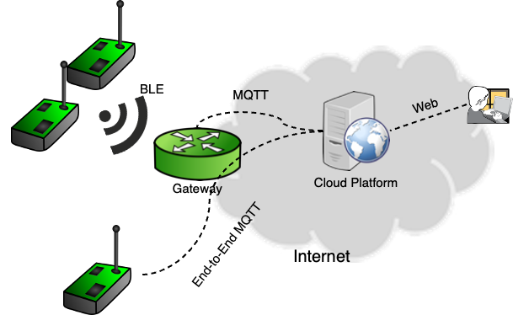
Figure 8: Two alternative architectures for home experimentation

Scenario 1: Use your own gateway and nRF54L15DK
For this scenario, you can use your own nRF54L15DK with the firmware that we developed during lab session 5.
You will also need to run the gateway software that was running on the teaching team's computer during the lab session.
The gateway software can be downloaded here:
GitHub - g-oikonomou/EEMEM0018-2025-26-Lab-BLE-Scanner: Code for the BLE Scanner/Gateway, to be used at the IoT Systems Prototyping Lab at the University of Bristol, academic year 2025/26
Follow the README file to install necessary packages and to familiarise yourself with the command line options and make sure you have the correct packages installed.

Register a gateway device on ThingsBoard
Create a new Device on ThingsBoard cloud using the "Customer Gateway Profile" Device Profile.
- Go to Devices / Add device / Add new device.
- Give a name to your device. Under "Device profile" select "Customer Gateway Profile". Finalise the creation with the "Add" button.
- Open the device's properties and press the "Copy access token" button.
- Back on your computer's terminal, store the copied token in the ACCESS_TOKEN environment variable.
  - On macOS and Linux this can typically be done with export ACCESS_TOKEN=<paste the value here>. You can verify it with echo $ACCESS_TOKEN.
  - On Windows (PowerShell), you can set the environment variable for the current session using: env:ACCESS_TOKEN="paste_the_value_here". You can verify it with echo $env:ACCESS_TOKEN.
If you do not complete this step correctly, the script will produce a "MQTT: Access Token not set" error when trying to publish data over MQTT.

Use a locally-installed MQTT broker (Optional)
Install an MQTT broker on your computer. You can use the same computer as the one running the gateway script, or a different computer in the same network. You can install any MQTT broker you wish. We recommend Mosquitto: https://mosquitto.org/
Run the gateway script with the -t option. If your broker is running on the same machine, this should work. If your broker runs on a different machine, you will need to specify its IP address using the -m option.
You can then use an MQTT client to view the messages that are being published. Simply subscribe to topic "#". For example, with Mosquitto you can use mosquitto_sub -h "localhost" -t "#". Pass the correct argument to -h if your subscriber and broker are running on different devices.

Push data to the ThingsBoard Cloud
To push data to the ThingsBoard Cloud, run the script with -t -b mqtt.thingsboard.cloud. You should then be able to see your device's telemetry updting on ThingsBoard Cloud and you will be able to view new telemetry in your dashboards.

Scenario 2: End-to-End MQTT with an Emulated Device.
Instead of deploying your own BLE-MQTT gateway, you can generate telemetry and interact with ThingsBoard Cloud using an emulated device. This can be achieved by running an MQTT publisher on your computer. Again, we recommend Mosquitto, but you can use the MQTT client of your choice.
This scenario is very useful if you wish to familiarise yourself with the ThingsBoard APIs.
ThingsBoard has excellent, extensive documentation and examples that would be meaningless to attempt and replicate here.

Scenario 3: (Optional, Advanced): Experiment with Alternative Transports
All our interaction with ThingsBoard has so far been over MQTT, but this is not the only choice. Devices can interact with ThingsBoard using a number of alternative protocols, for example HTTP(S); MQTT Sparkplug; CoAP; LwM2M; SNMP and more. For more information visit the "How to Connect your Device" page on the ThingsBoard Documentation space.
If you wish to experiment, we recommend starting with HTTP. If you have also taken the Advanced Networks unit, you may wish to also try CoAP.

References
[1] T. Bray, The JavaScript Object Notation (JSON) Data Interchange Format, RFC 8259, Internet Engineering Task Force
[2] MQTT: The Standard for IoT Messaging, https://mqtt.org

